Installing and maintaining hardware give’s many benefits for the organization, proper installation ensures that systems function quickly; with lots of performance, reducing the risk of crashes, slow performance, and other issues that can harm productivity. Furthermore, it also enables faster processing and efficient data management; smoother operations of business applications like word, power point, excel. Regular maintenance, such as updating drivers, uninstalling software that is not important can free up RAM and improve system performance on the system by manging data for faster access. These improvements can lead to faster processing time and less strain on the CPU, reducing lag, and overall improving performance, which can boost productivity and user experience. Furthermore, if we keep the current systems in place then we can just install new parts improving their performance mean that you won't loss clients by your systems being down due to changing them. Another point we could upgrade the monitors of everyone's pc to improve graphics performance so that things can render better and quicker.

The Business face several major risks when decommissioning their systems, primarily stemming from operational, financial, security and compliance difficulties. This are key risk if decommissioning system 2, furthermore there could be potential data loss or corruption if data migration and backups are not properly managed during decommissioning. This could also impact operations if the decommissioning is not properly assessed as I stated before you could lose data on client’s and this could affect pay roll for employs. Another point to add is compatibility running outdated systems that are no longer supported by venders poses a major security risk, as they could become vulnerable to cyber threats and are often incompatible with modern security standards, this lack of support can also lead to non-compliance with regulations such as GDPR, which may result in legal penalties and reputational damage which can harm the business in the long term. We also have to look in to training staff, if we decommission system 2 then the staff who are already use to using the old system will have to be re-trained for the new system which could mean spending money on re- training and loss of time, efficacy and money as work might not be as satisfactory for the client.

If we look at system 1 the CEO’S printer is quite out of date and i would recommend switching to a HP OfficeJet Pro 8134e All-in-One Wireless Printer | Scan & Copy | 6 Months Free Instant Ink with HP+, as it has everything the client want as it can scan and copy paper files in to the database furthermore it would be cheaper to replace the current printers then upgrading them to have scan and copy furthermore the client could just maintain the printers and upgrade the new ones over time to have them keep up which will save them money in the long run, another thing to add is that the printer can connect to the Wi-Fi network meaning it lets the client send files from there phone to the printer to print. If we now look at the CEO’S personal computer the reason it is running slow may be due to the hardware being out of date i recommend changing the CPU and RAM to increase performance, we could also upgrade the power supply to the computer as well which will also boost performance. CPU i recommend switching to is AMD Ryzen 5 5500 3.6 GHz 6-Core Processor, RAM i recommend adding is Corsair Vengeance LPX 32 GB (2 x 16 GB) DDR4-3200 CL16 Memory, and the Power supple i recommend is MSI MAG A750GL PCIE5 750 W 80+ Gold Certified Fully Modular ATX Power Supply.

Alex search this on brave: what are some benefits of installing and maintaining hardware

And search this: what are the risks for a business to decomison there systems

Certainly! Here's a list of the **components and specifications** of the **Epson Stylus Color 440 inkjet printer**:

* **Printing Technology**: Piezoelectric on-demand inkjet
* **Nozzle Configuration**:
  + 64 nozzles for black ink
  + 3 sets of 21 nozzles for cyan, magenta, and yellow ink
* **Paper Handling**:
  + Friction feed paper feeder
  + Supports paper types: A4, Letter, B5, Legal, envelopes (No.10, DL, C6), A6 index cards
  + Paper capacity:
    - 100 sheets of plain paper
    - 65 sheets of photo-quality inkjet paper
    - 30 sheets of photo-quality glossy film
    - 10 sheets of transparencies
    - 10 envelopes
    - 30 photo-quality inkjet cards
* **Interface**: Centronics®-type 8-bit parallel interface (IEEE-1284 nibble mode)
* **Ink Cartridges**:
  + Black cartridge (S020187): Up to 540 pages at 3.5% coverage (ISO/ECMA)
  + Color cartridge (S020191): Magenta, cyan, yellow (combined capacity up to 300 pages at 5% coverage for each color)
* **Control Panel**:
  + Power, paper out, ink out (black), ink out (color) indicators
  + Functions: Ink cartridge replacement, cleaning, load/eject
* **Environmental Requirements**:
  + Temperature: 10° to 35° C
  + Humidity: 20% to 80% RH (no condensation)
* **Power Requirements**:
  + AC 220 to 240V at 50 to 60 Hz
  + Power consumption: ~15W
* **Dimensions**:
  + Width: 429 mm
  + Depth: 275 mm
  + Height: 168 mm
  + Weight: 5.2 kg (excluding ink cartridges)
* **Supported Operating Systems**:
  + Microsoft Windows 3.1, 95, 98, NT Version 4.0
* **Additional Features**:
  + On-line guide via CD-ROM

Let me know if you need more details!

<https://www.currys.co.uk/products/epson-ecotank-et2870-allinone-wireless-inkjet-printer-10261759.html>

<https://www.currys.co.uk/products/hp-officejet-pro-8134e-allinone-wireless-inkjet-printer-with-fax-and-instant-ink-with-hp-10259013.html>

https://www.ebay.co.uk/itm/227016246749?_skw=HP+OfficeJet+Pro+8134e+All-in-One+Wireless+Printer+%7C+Scan+%26+Copy+%7C+6+Months+Free+Instant+Ink+with+HP%2B&epid=7066301572&itmmeta=01K8ANHB73WEZS52SP3VVWNNWG&hash=item34db3905dd:g:0noAAeSw79Jo57fc&itmprp=enc%3AAQAKAAABIFkggFvd1GGDu0w3yXCmi1dvoKgpbeTajhtJyKuoDS2pnVz8E%2BRRmCg2gjC1Y2AAgsYkZfi16dToO%2F6k67FPBpaLh8cNlwNo%2BZPXRWiEm2NstmP5cwPh86K7qC1FiU%2Bb0ZMKr7X6ywdp8EskJt99X5OnYRMO5xIf%2BtfqD%2FQW8n32fZfgSmA40ZbUHHib%2FfV5BSzuObmXnu0a2u--rgoF4hxreOGyUyGWKI0Vp%2FDbPbc1S6agqSGWZk4tBOYSIuo1WNZi3YHZfM6aF%2B988nbN%2Bxv%2F7bbUV3IEOgc4LlAn32J4TyQE1UTBy4kq0Oc5Nqs8f4KTP5XkEjaQfLCA7RycG46V2iUJPW4qp9dmgO5h3J8YPA298bQ7XqLDExluQh7Y9g%3D%3D%7Ctkp%3ABlBMUOKzxdXCZg

<https://quillbot.com/ai-content-detector>

<https://plagiarismdetector.net/>

**Task 2**

The objective of installing and maintaining hardware within west Mercia employment technology systems is to make sure that all computers work with a high level of speed, efficiency and reliability making it so staff can carry out essential business task without any disturbance. The client (west Mercia employment) needs system that can use software like Microsoft Word, Excel and PowerPoint over a 24 hour period without stop. These are important for managing their client records, assembling CVs, producing job information packs and talking with employers. Another point to add is the client (west Mercia employment) need strong servers with the best CPUs and high-performance air coolers (dual-fan model Noctua NH-D15) to keep up with the required up time for the servers.

Upgrading and maintaining the hardware will reduce system crashes, minimise slow performance and stop data-processing delays all of which are right now impact productivity in both the CEO’s office and the general office. Regular maintenance activities such as regularly updating drivers, getting rid of unnecessary software and manging system resources will make sure that each device operates at its best capability and stay compatible with the latest software and security requirements.

The client also needs a stable and efficient system that allows staff to access data fast when matching candidates to free spots. Improved hardware performance: minimises downtime, aid multitasking; and better the user experience making sure staff can work at the pace required to meet business demand. Strong system reliability is essential to prevent disruption to customer communication, protect data integrity and maintain trust with employers and job seekers.

|  |  |  |
| --- | --- | --- |
| Hardware Upgrade (CEO system 1) | Remove old CPU and install AMD Ryzen 5 5500 | This Improved processing speed and performance |
|  | Install 32 GB Corsair Vengeance DDR4 RAM | This Support multitasking and faster data access |
|  | Replae PSU with MSI MAG A750GL | This Increase Power stability and reliability |
|  | Replace outdated inkjet printer with HP officejet Pro 8134e | This Provide scanning, copying and wireless printing |
| Hardware Upgrade (General office system 2) | Maintenance check on all 18 stand-alone computers | This Ensure reliability and find faults |
|  | Clean internal comments to get rid of stuff like dust and check for component durability | This Stop overheating and make the life of the device’s lifespan last longer |
|  | Look at the printer's condition and change parts if required | This Upgrade printers' quality and reduce paper jams |
|  | Update drivers and firmware | This Maintains compatibility and make stability better |
| System Maintenance Task | Delite unnecessary software | This Free system resources and make the speed faster |
|  | Run Disk clean-up and defragmentation on the HDD | This Make the storage more optimised for performance |
|  | Apply regular system updates for performance and security | This Maintains system security with GDPR compliance so there are no issues |
|  | Make regular backup’s and schedule them | This prevents data loss during upgrades |
| Documentation Tasks | Record hardware changes | This Maintains accurate logs of all changes |
|  | Updates components installed | This keeps a record of the components installed |
|  | Make staff guidance better on new hardware | This reduces people making errors after upgrading |

**CEO’s hardware requirements**

AMD Ryzen 5 5500 3.6GHz CPU

Corsair Vengeance LPX 32GB (2×16GB) DDR4 RAM

MSI MAG A750GL 750W Power Supply

HP OfficeJet Pro 8134e All-in-One Printer

Thermal paste for CPU installation

Anti-static wrist strap

Replacement power cables if needed

**General office Hardware requirements**

Compressed air for cleaning internal components

Replacement inkjet printer or EcoTank model

Spare keyboards/mice if faults detected

Replacement SATA/Power cables

**Software Resources**

Newest CPU; GPU

Lunix arch updates

Anti-virus software

Backup software like one drive or any other form of cloud storage or external hardware

Software diagnostic tools like malware bites or any other form of them.

**Tools that can be used for diagnosing the pc**

Task manger – lets you check the CPU; RAM usage

BIOS diagnostics – checks the hardware

Memory tool test – used to find faults in RAM

Anti-virus scanner – to identify malware

**Techniques in finding problems**

* Substitution – swapping faulty hardware with working hardware as an alternative
* Error Log check – checking recurring system errors
* Performance Monitoring – Looking at the CPU, RAM and disk activity under load
* Visual Inspection – checking for dust any loose cables and overheating or even physical damage
* Re installing components – take out and reinstall RAM, cables or expansion cards to get them to work
* Safe Mode test – Finding any problems in the hardware or software

**Test Plan**

|  |  |  |
| --- | --- | --- |
| Power on test | To make sure the CPU, RAM and PSU are installed correctly | The system loads up with no BIOS errors |
| Checking BIOS hardware | Making sure the new components are found | Seeing the CPU and the full 32GB RAM is found |
| Operating system boot up test | Checks the operating systems speed to turn on and its stability | We did this test to see if the boot time was under 30 seconds |
| CPU stress yest | Test the stability of the CPU under a lot of loads | To make sure the CPU is not thermal throttling or crashing |
| Checking the RAM | Finding any memory problems | To test if there are any errors |
| Printer Test | Making sure the drivers and compatibility is good | Printing something on the printer to make sure it works |
| Scan and Copy for the CEO’s printer | To make sure the all the functions work properly | Scanning some documents and checking if they appear on screen |
| Testing the software | To make sure that the speed we get the data at is quick | Oping Ms power point or any required applications with no problem |
| Ask staff if the systems are quicker | Making sure the staff know how to use the software | Doing a survey to get some feedback on the performance |

Before finalising anything on the upgrades and maintenance on the current systems, at West Mercia Employment. There are a couple of alternatives we can use for hardware and system solutions which we considered based on the evaluation we did on coast, disruption to the business and compatibility with existing software, another point to make is that we also looked at how quickly staff can adapt to it and the long term usability.

**The first alternative**

**Full system replacement meaning all new PC’S**

This option like the name says means we must scrap all the current systems and replace them all, meaning all new computers for the 18 staff members and CEO along with new peripherals and printers to insure compatibility with the new system

**Reasons client might reject this idea**

* The cost will be too high for purchasing all new systems and making new users meaning it will exceed the company's budget
* Downloading and configuring new systems would mean the servers would have to be down which would affect the company's daily operations and client communications
* Data migration is a huge risk as if the data is not transferred properly, it could corrupt or all the data could be lost
* It could reduce productivity in the short terms as the staff would have to train on the new system
* It would be un-needed as there is still hardware which we can replace with targeted upgrades and maintenance

**Impact on staff and CEO**

This in total will delay training on new systems and will lead to system downtime along with a reduction in efficiency.

**The second alternative**

The second alternative solution we have found is doing a cloud-based hosting meaning the staff access their desktops remotely through a server rather than a local machine

**Reasons client might reject this idea**

* The subscription fee would increase long term cost
* This is internet dependent meaning it requires internet to access everything and if there is a black out then there will be down time
* There will be new GDPR compliance rules we would have to comply with due to all the personal data that would be handled on the cloud servers
* This will be unnecessarily complicated as the business does not need it.

**Impact on staff and CEO**

The staff would be less productive if the internet is slow due to this method reeling heavily on internet

**The third alternative**

The third options involve fixing and repairing problems without upgrading hardware

**Reasons client might reject this idea**

* This will limit the performance and slow processing speed and limit multitasking.
* Some component's are more likely to fail due to them needing to be changed.
* The old hardware may struggle when loading the new applications and multitasking

**Impact on staff and CEO**

The CEO and staff would still experience slow performance and limited efficiency

**The Final Decision Justification**

The final decision to improve, upgrade and maintain the existing technology systems at West Mercia Employment best soot's the client requirements, by improving the already existing key hardware components such as the CPU, RAM, power supply and printers the systems will increase the processing speed; improved reliability along with better compatibility with modern applications. These improvements directly support the business daily operations of the company. For example, the need to manage client data and produce documentation and communication quickly with employers and job candidates. The maintenance of the existing systems rather than changing them entirely makes the risk of data loss reduced greatly which also ensures the continues of service. Staff can continue working on familiar systems with minimal disruption which is important in a recruiting environment where quick responses and access to files are critical. The upgraded hardware will allow employees to do multiple tasks efficiently when matching candidates to open spots increasing the productivity and improving user experience. The installation of all the modern printer feacher supports the clients requirements for producing both electronic and hard-copy's of information, scanning and copying is a feature which enables paper documents to be copyed digitally and quickly improving data management support and copliance with the GDPR records. Overall the selected solutions provides a cost effective and reliable solutions and scalable apporach that meets both current and future business needs.

**Impact constraints of the plan**

Five constraints were found during the planning process and influenced the last decision

**Budget constraints**

The client operates as a small business with a limited budget, this restricts the plan of a full system replacement or cloud-based solution, because of this we are using targeted hardware upgrades to maximise performance improve while keeping costs manageable.

**Time constraints**

The system downtime when upgrading need to be minimised to avoid disruptions to daily recruitment tasks. Furthermore, upgrading existing systems allows the client to work in stages esusing business operations can continue smoothly while miniatous is made.

**Compatible constraints**

Existing software and data formats had to remain compatible with the upgrades done on the hardware, replacing systems entirely could have introduced software compatibility issues and will required more licensing meaning more costs. The chosen solution avoids these risks by retaining the current operating environment

**Data protection and security constraints**

The company handles sensitive personal data and employment data making data security and GDPR compliance a priority. Maintaining the current systems reduces the risk of associated with large scale data movement and esures existing security controls in place

**User skills and training constraints**

The staff’s familiarity with the existing system influenced the desison to upgrade rather than replace due to them already knowing the current system. We feared that the staff’s productivity would go down due to them needing to learn a new system The selected method allowes staff to use the same system and continue working effectivly with minimal learning requirements.

**Task 3**

**Data backup and system preparation**

Before we carry out any maintenance or upgrades a full backup of all systems and setting was completed to make sure that sensitive data and business data is not lost during the process. This included employee records and candidate database; system configuration files. The backups were stored securely using both a cloud-based storage and a storage device to ensure that we have no redundancy. System restore points were also created to allow the system to be changed back if any problems happen during the installation, this approach shows the use of the tools and techniques to protect data and system settings, this meains that the user requirements and GDPR compliense were considered and met.

**Fault finding and fixing the internal hardware faults**

We found two different hardware faults and resolved them:

Fault 1: Not enough RAM causing slow performance

The performance monitoring tool we used was task manger to find were all the memory consumption was happening which was causing the slow system response and making the applications lag. The fault was fixed by removing the current low RAM and installing a new high capacity RAM module, this then was tested to ensure that the RAM was correctly detected and working.

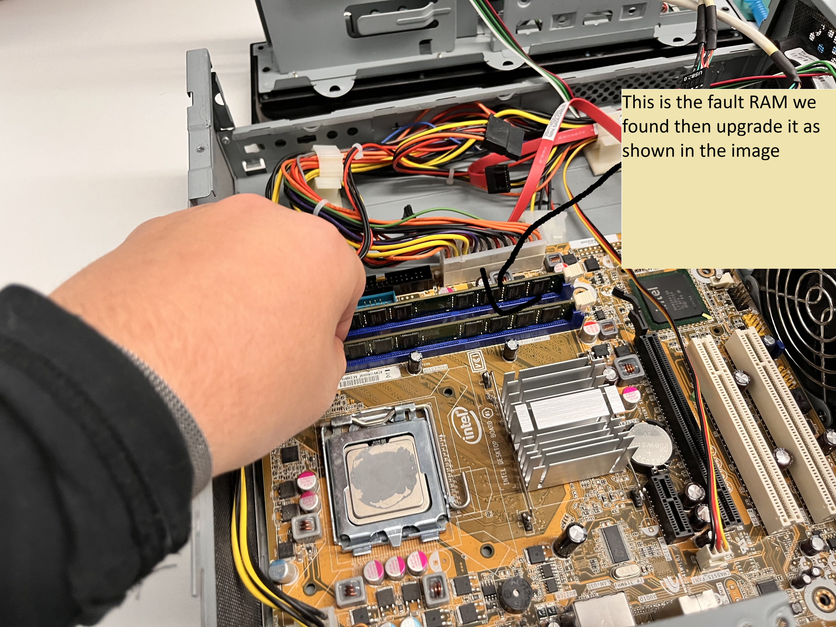

Fault 2: The power supply was unstable

The system was reported to randomly shutdown we traced to a failing power supply unit, we took apart the computer to make a visual inspection and did a power test to confirm out suspicious there was inconsistent voltage output. We then removed the faulty PSU and replaced it with a higher rated and more reliable power supply to improve system stability and reduce the risk of component damage.

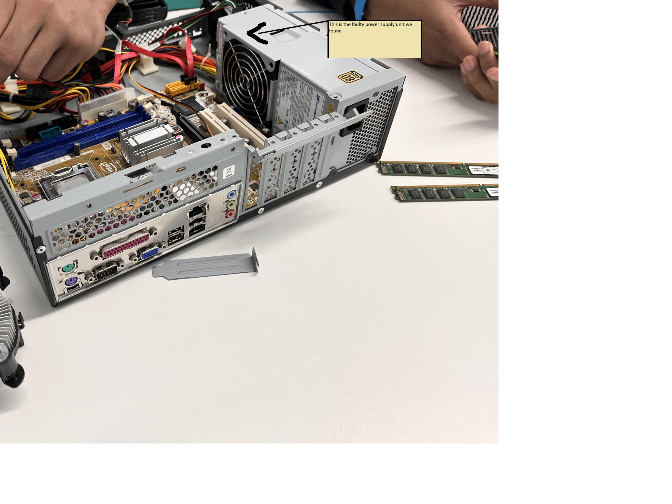

The repairs in the images show the effective fault-finding techniques and repairs of the 2 faults we found.

**Installation and configuration of internal hardware components**

As part of the system upgrade we installed 2 hardware components and configured them:

* We installed new RAM to improve performance and allow for more multitasking.
* Additional we installed a new power supply to enhance computer and ensure no random shutdowns occuser during opration of the computer.

Anti-static precautions were taking to ensure the safety of everyone when removing the components and installing them and to insure there is no hardware damage, after installation we checked the BIOS to ensure that everthing was correctly installed and recognised along with the correct drivers were updated to ensure full compatibility.

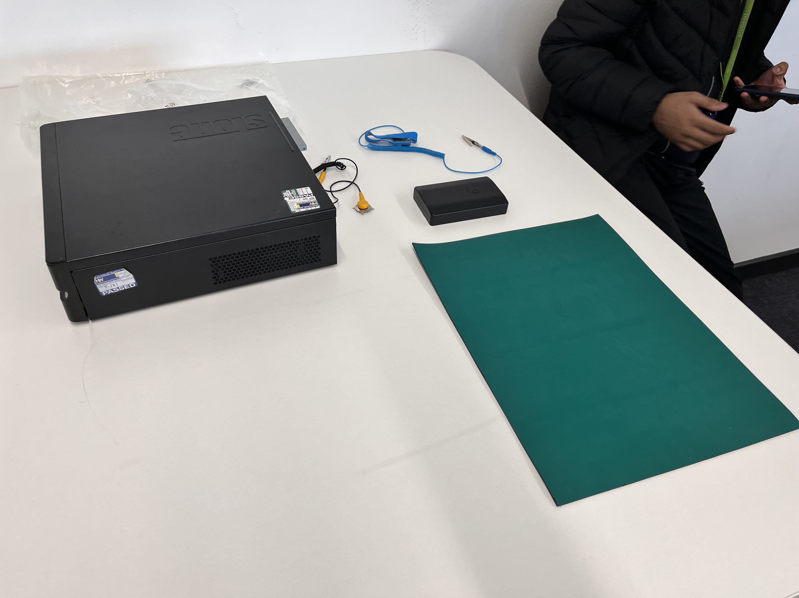

In this image you can see the tools we used to insure the anti-static protection a plastic mat, anti-static grist strap.

**Installation and configuration of external hardware device**

An all-in-one printer was installed which is also wireless. This was insalled as an external hardware upgrade, the device was connected to the system, we had to configure the correct dribers and test for printing and scanning along with copying functionality. This upgrade supports the specific requirement the client has asked for producing both electronic and hard copy copies of documents, it also improves workflow efficiency within the company.

**Data and system restore**

Once everything was installed, we restored all the data and system setting from the previous crated backup. We also did a file integrity check to make sure there was no data loss and all the user profiles and software were confiured and verified properly to ensure that staff could continue to work with no disruptions

**System testing and performance verification**

We test the modified technology systems to make sure that everthing was functioning properly and performance did improve. The test we did:

* Boot time performance testing
* CPU and RAM stress testing
* Printer test pages and scan verification
* Software application testing
* File access and data retrieval testing

The results showed improvement in all systems and all faults were fixed properly.

**Feedback**

We gathered feedback on the new system changes and performance; usability and overall, the client experience was good the staff were able to get back to work quickly and efficiently

|  |  |  |
| --- | --- | --- |
| Task | Yes | NO |
| Upgraded computes with new RAM |  |  |
| Upgraded computer with new power supply |  |  |
| Use safety equipment when oping computer |  |  |
| Make safety back up point |  |  |

**Evidence**

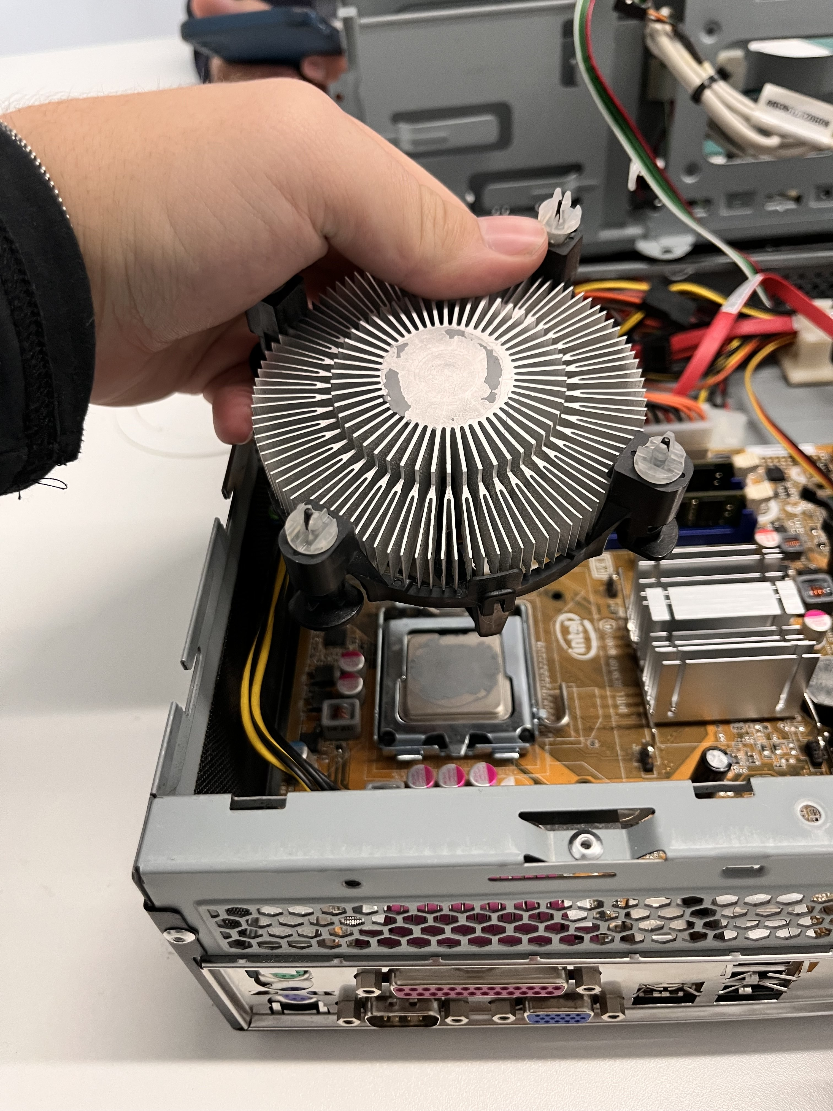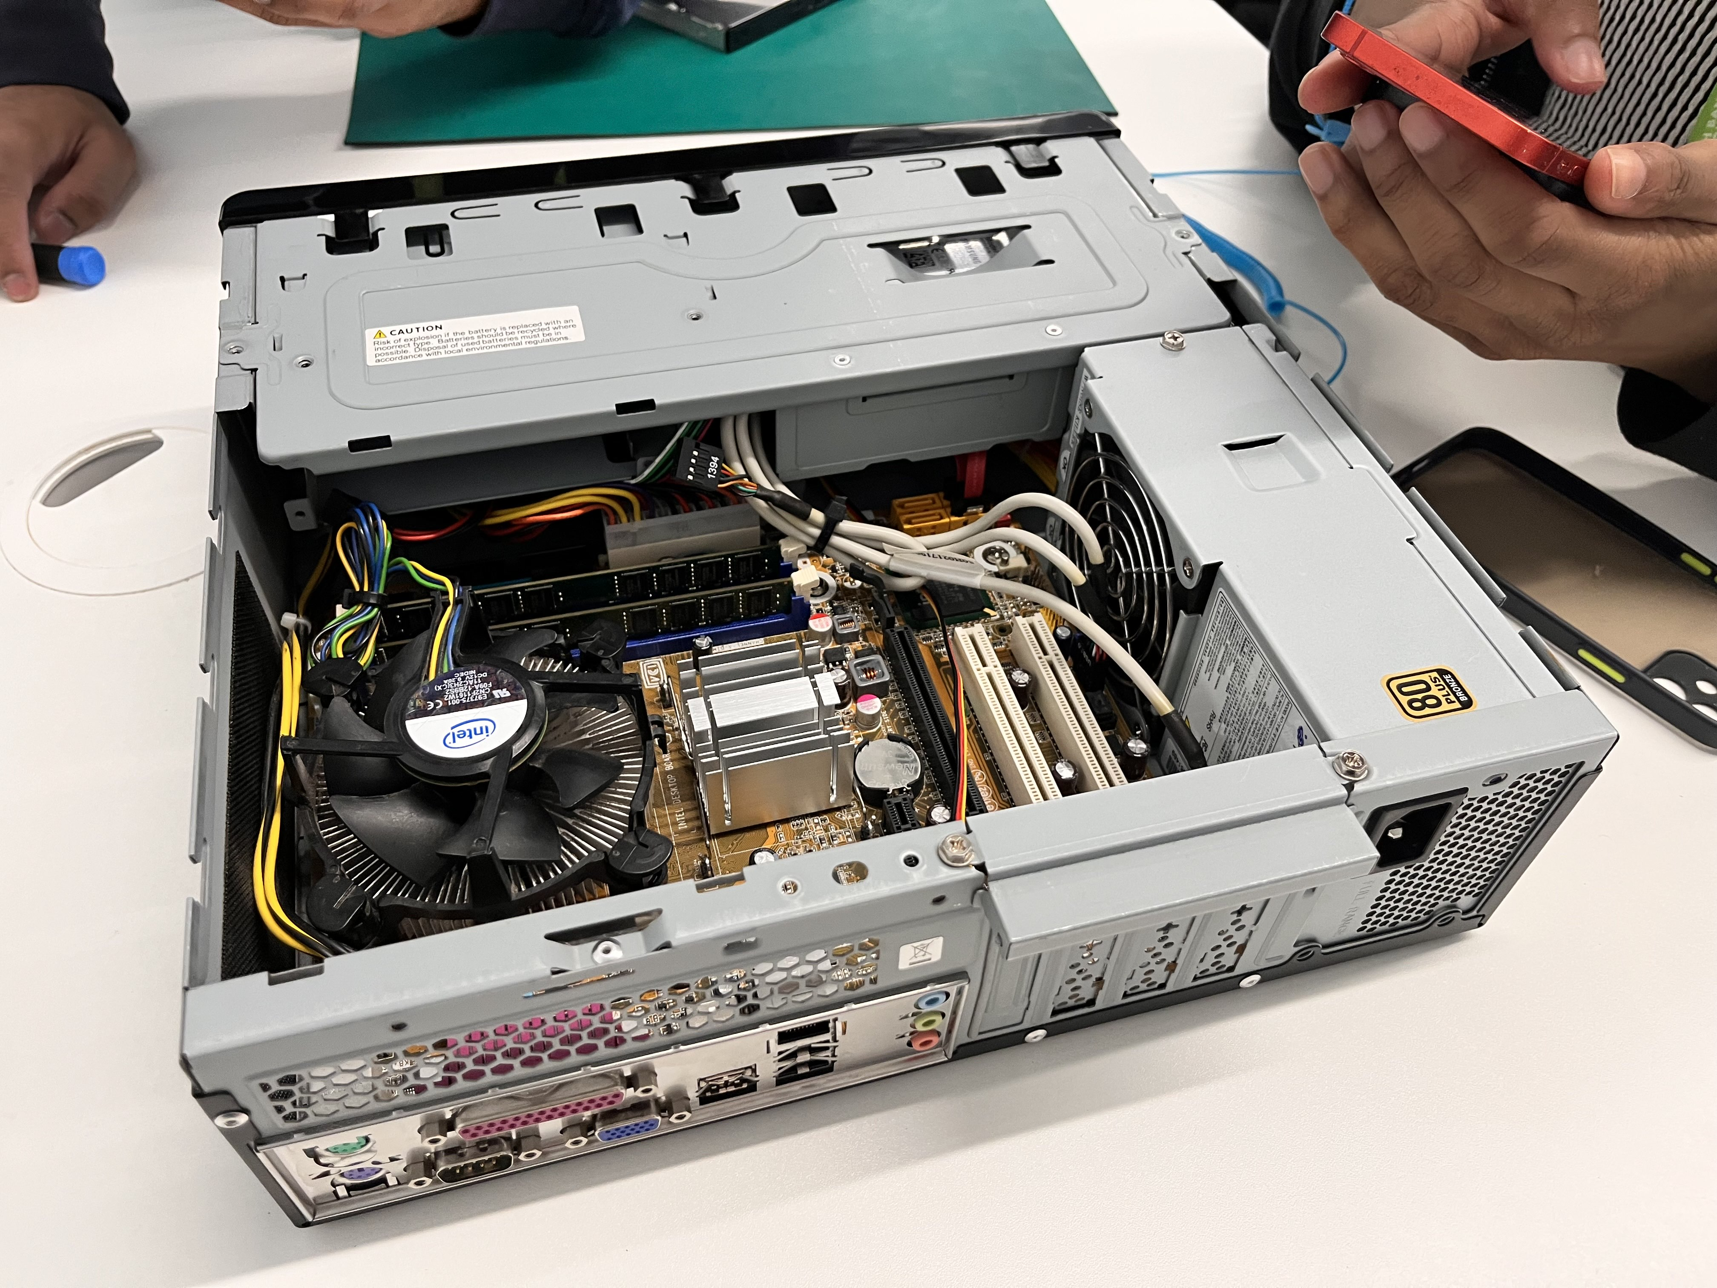

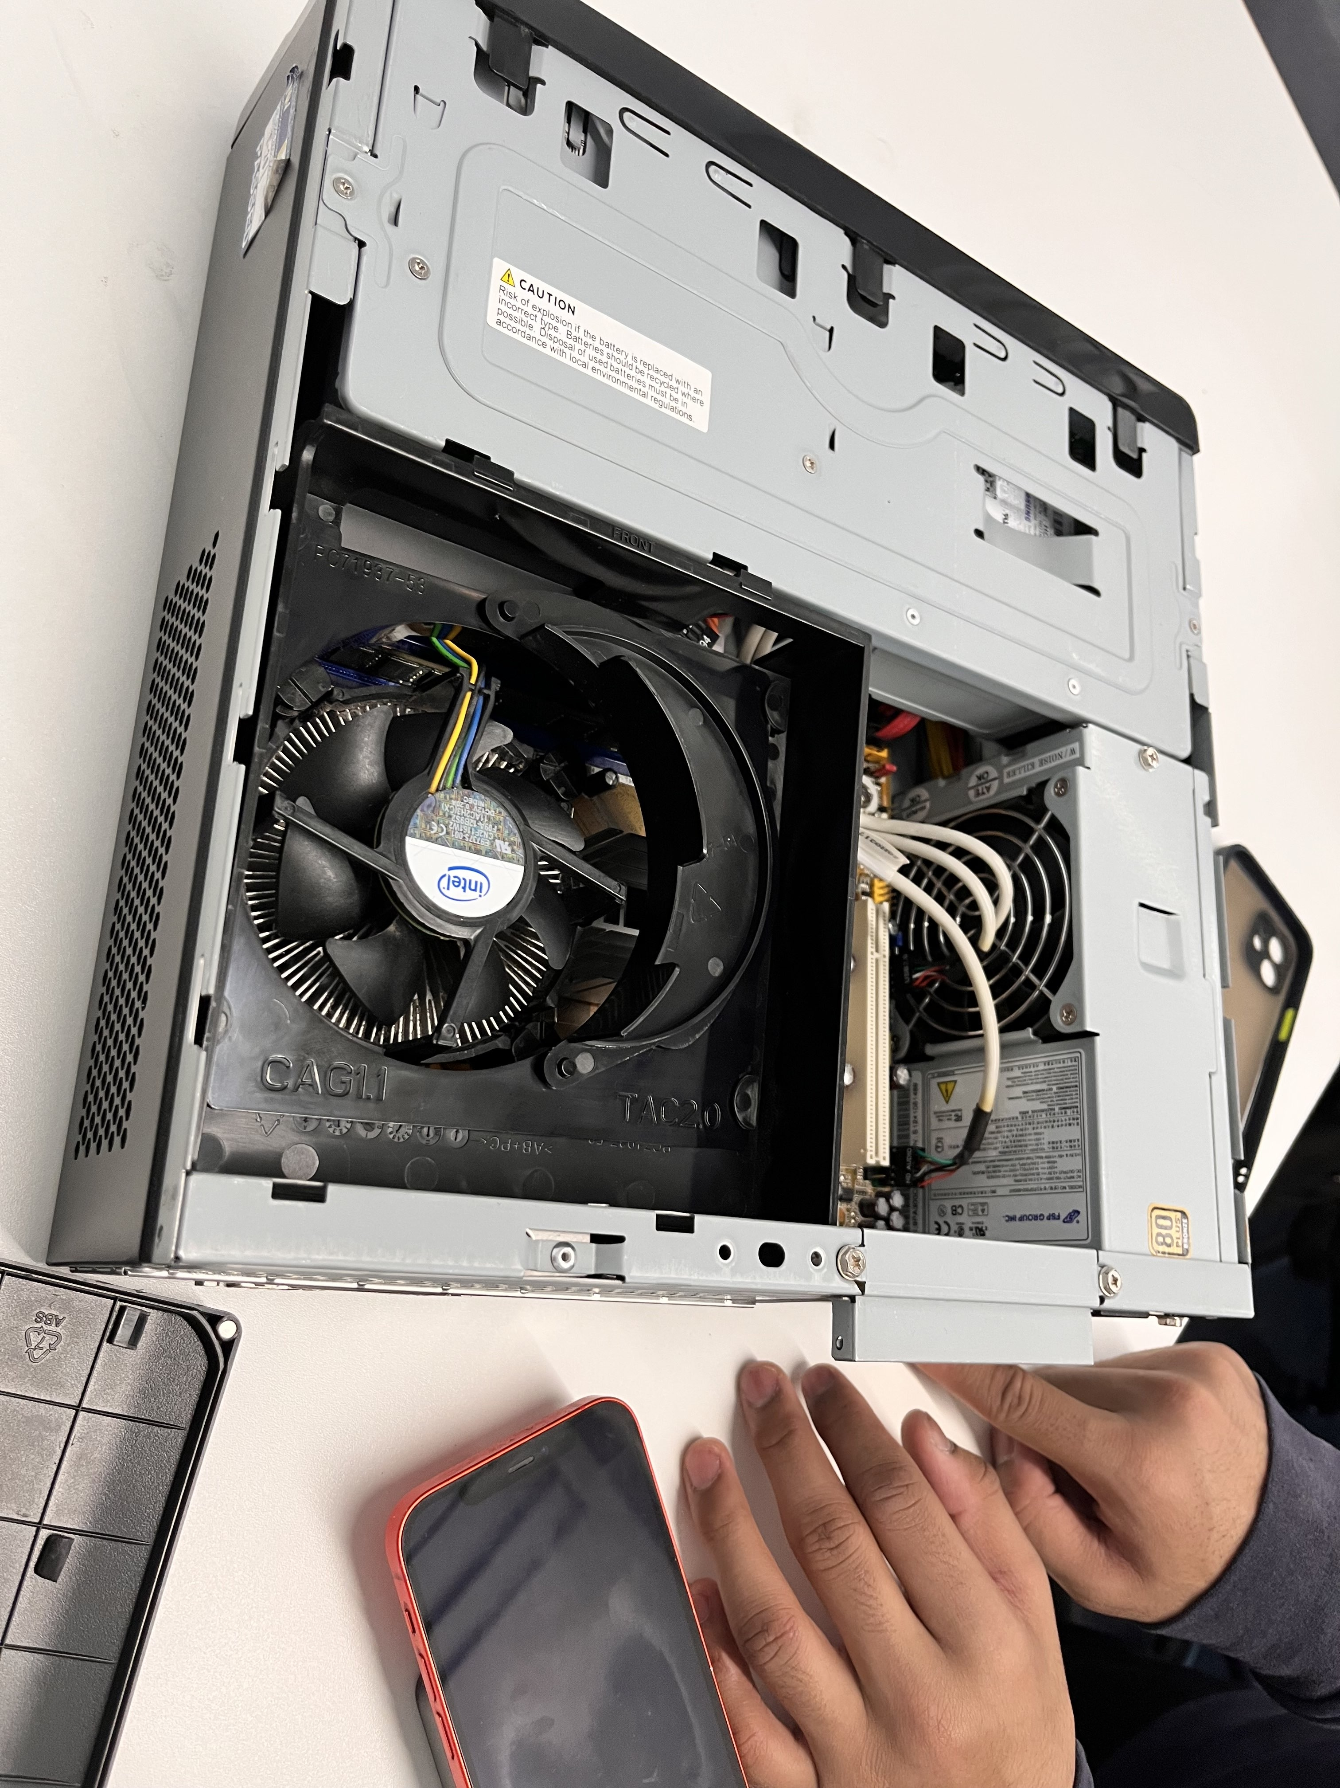

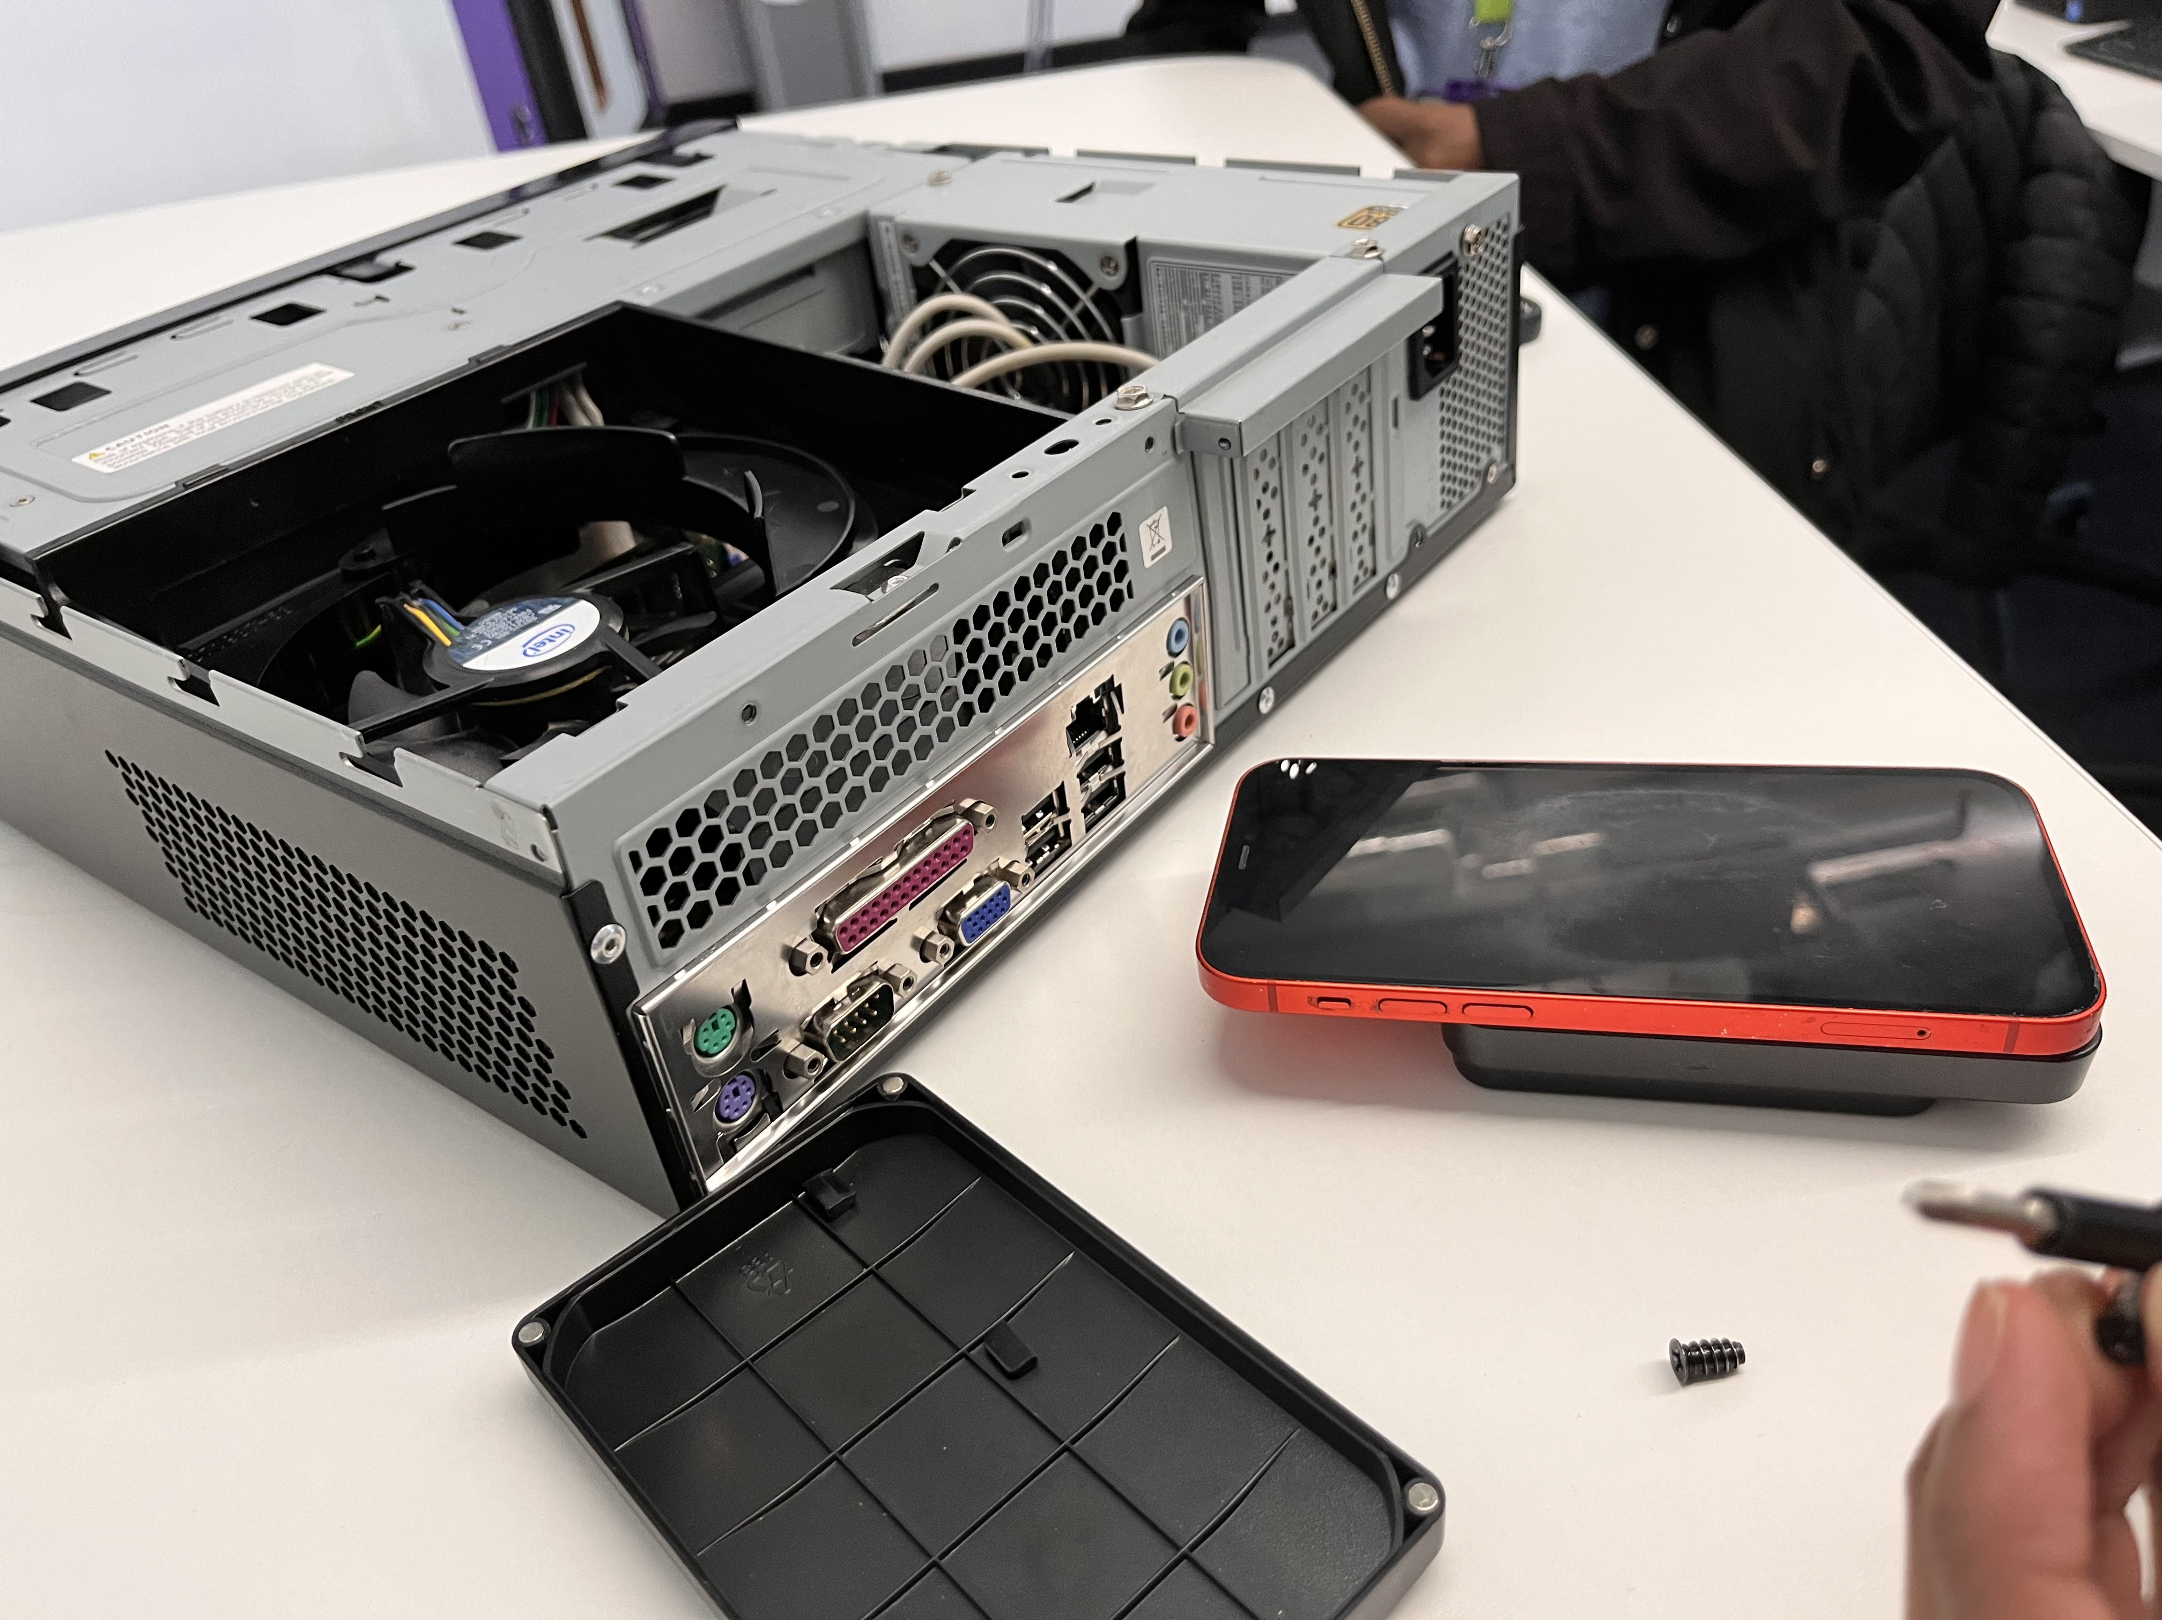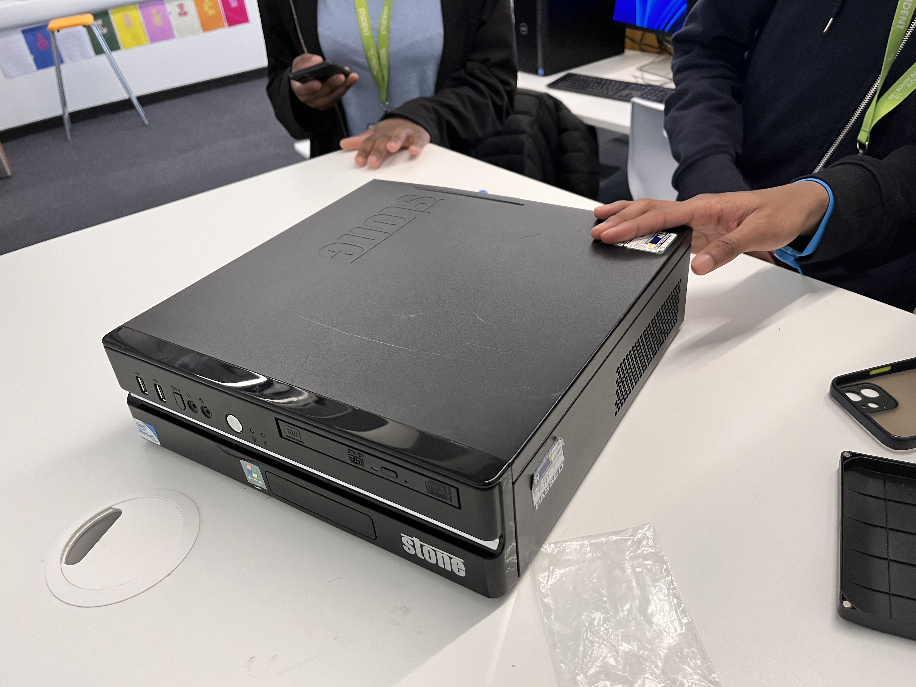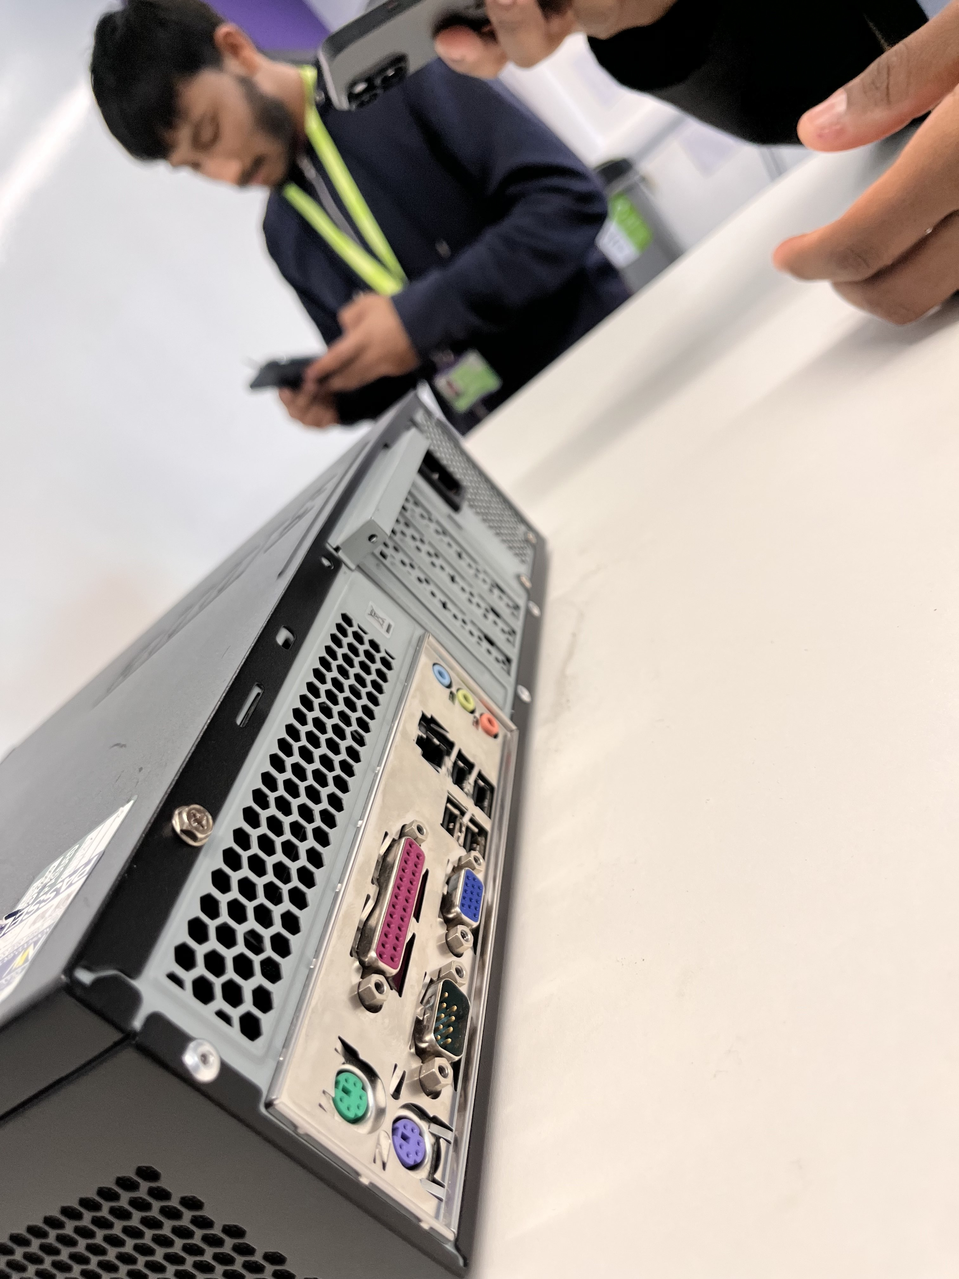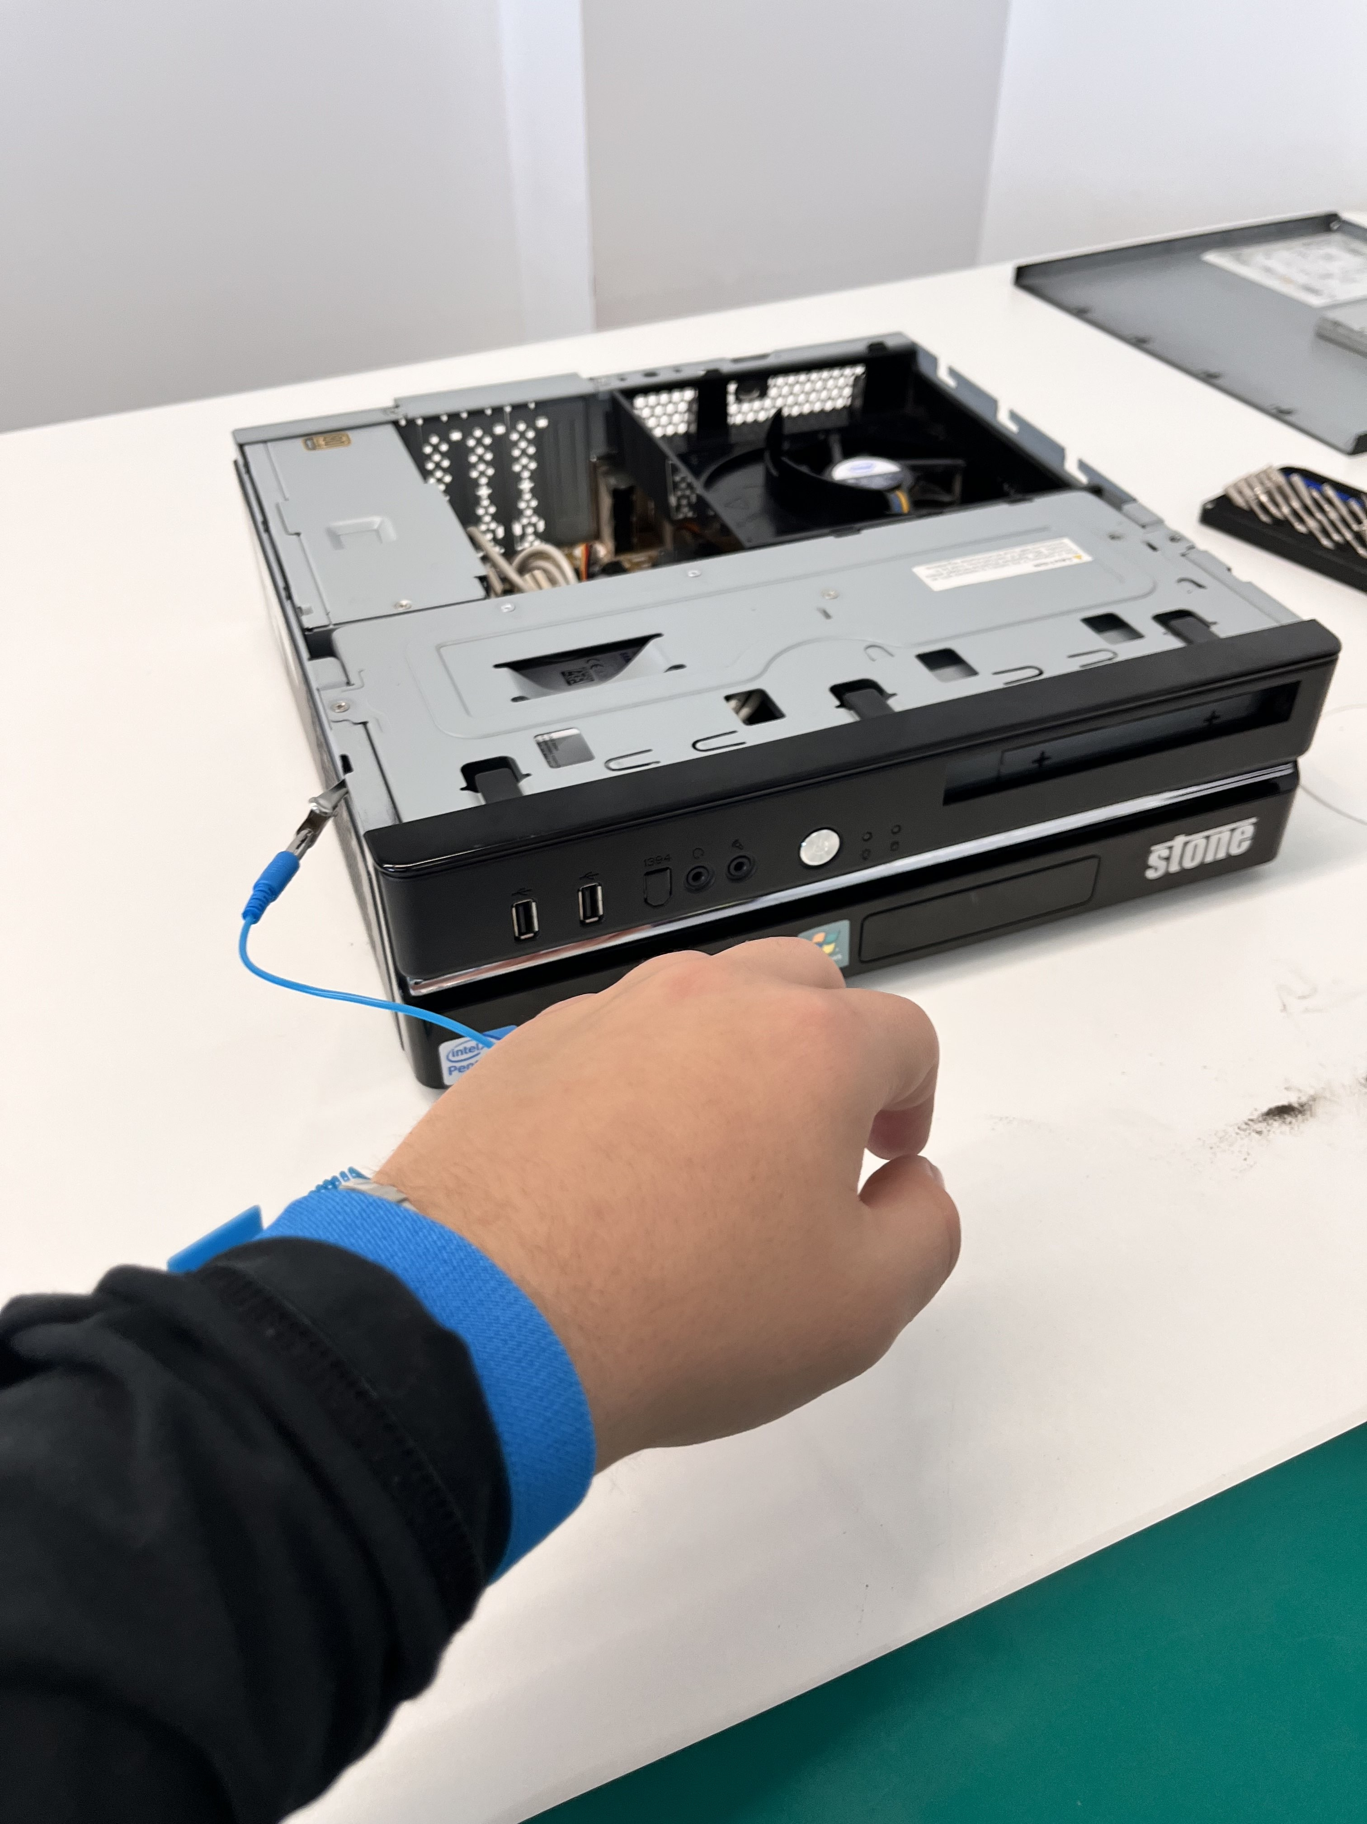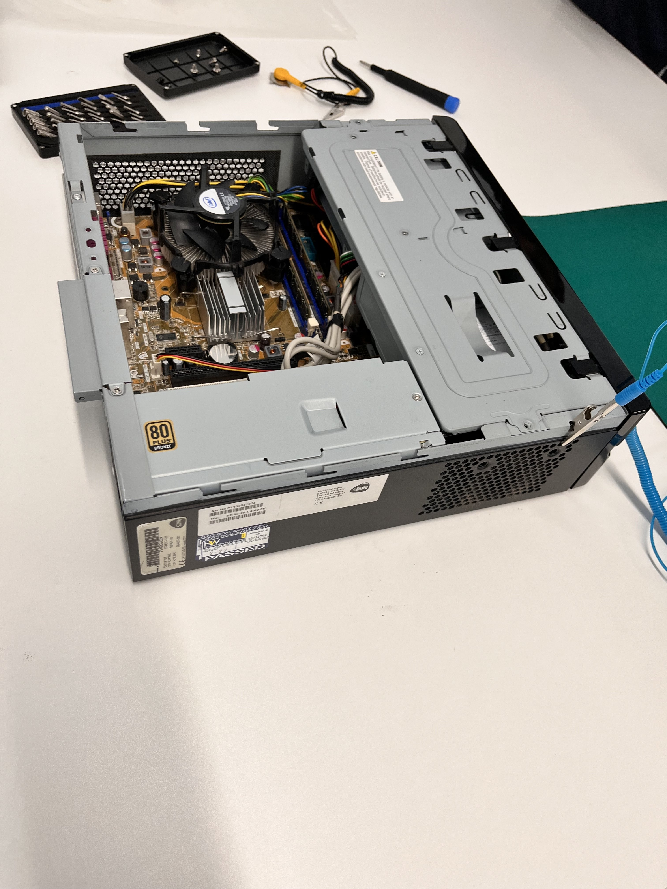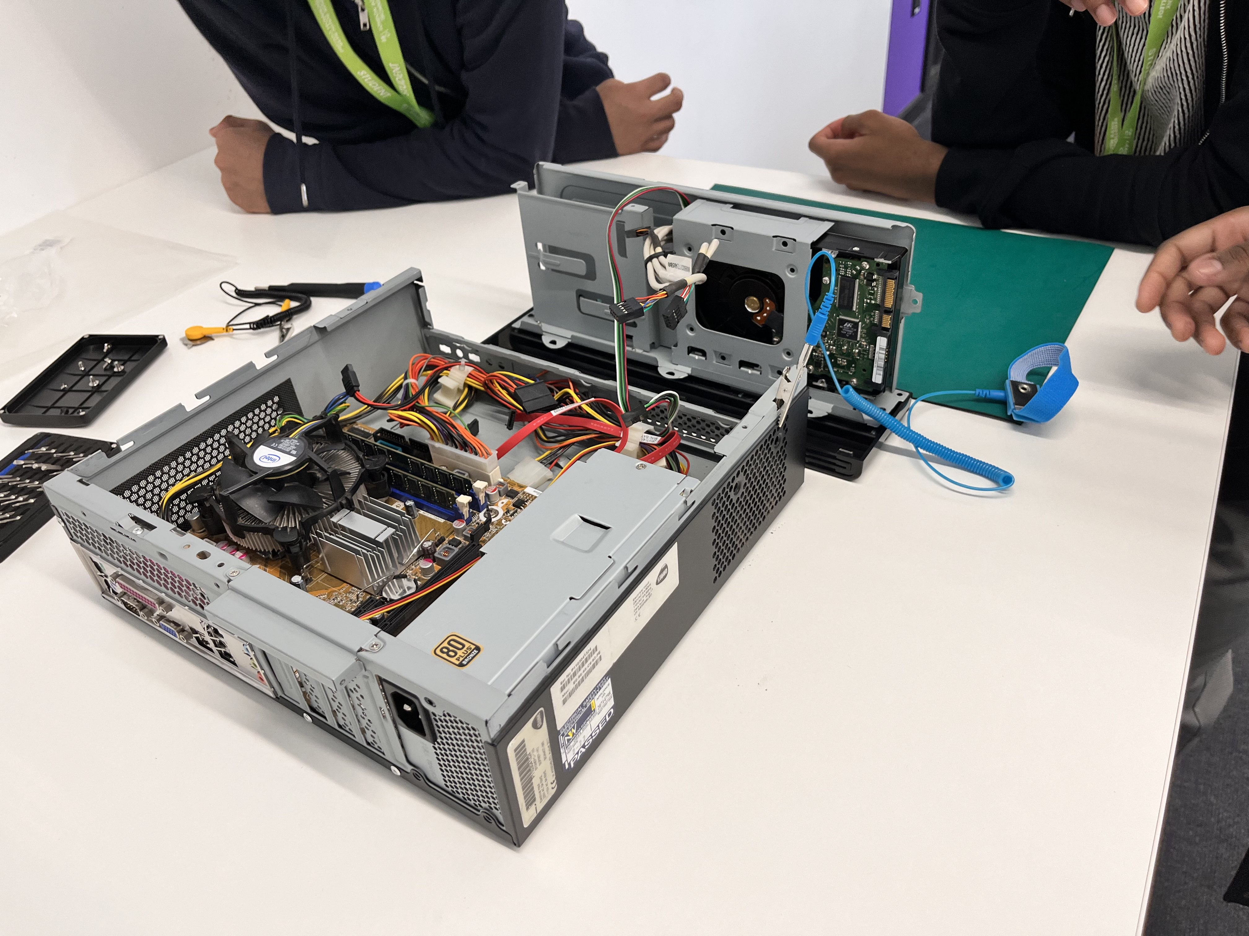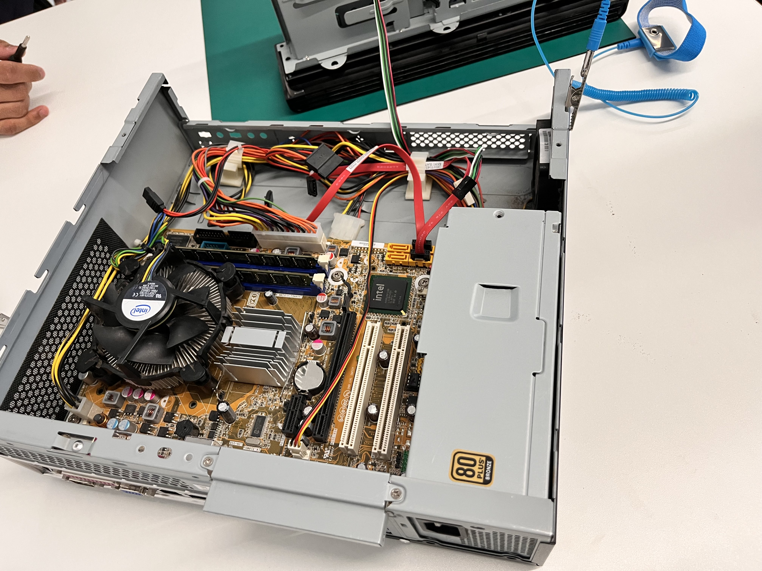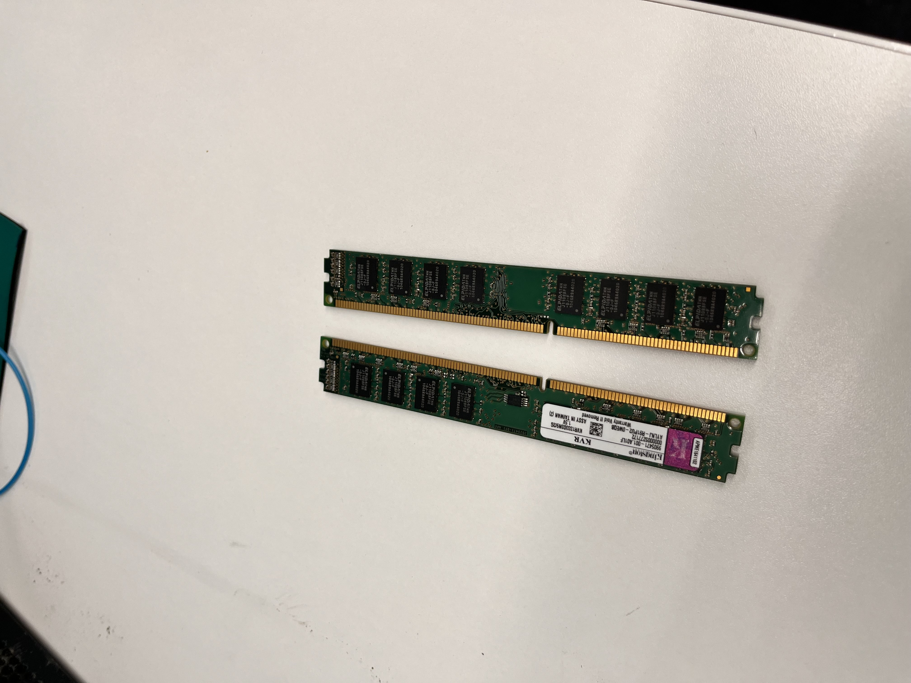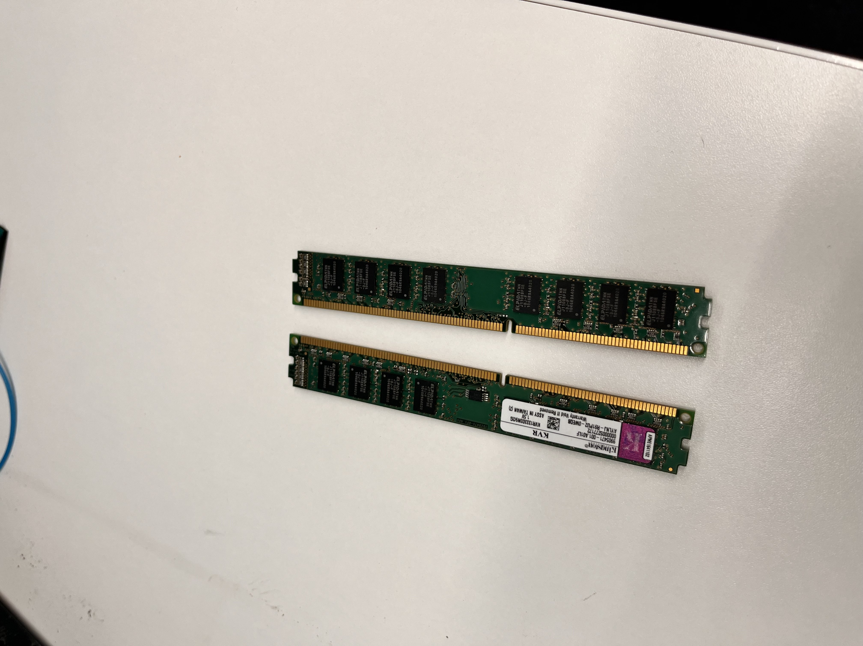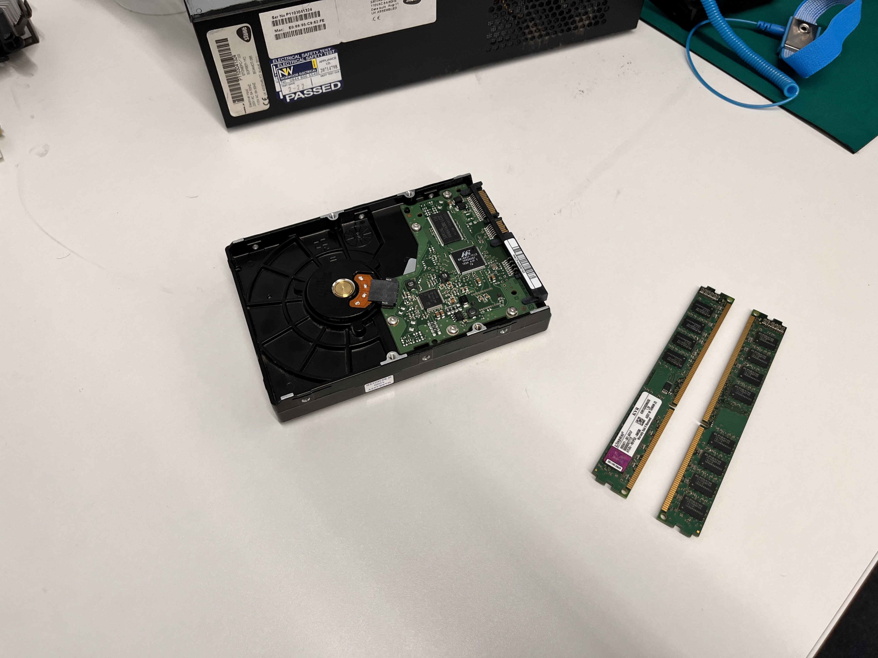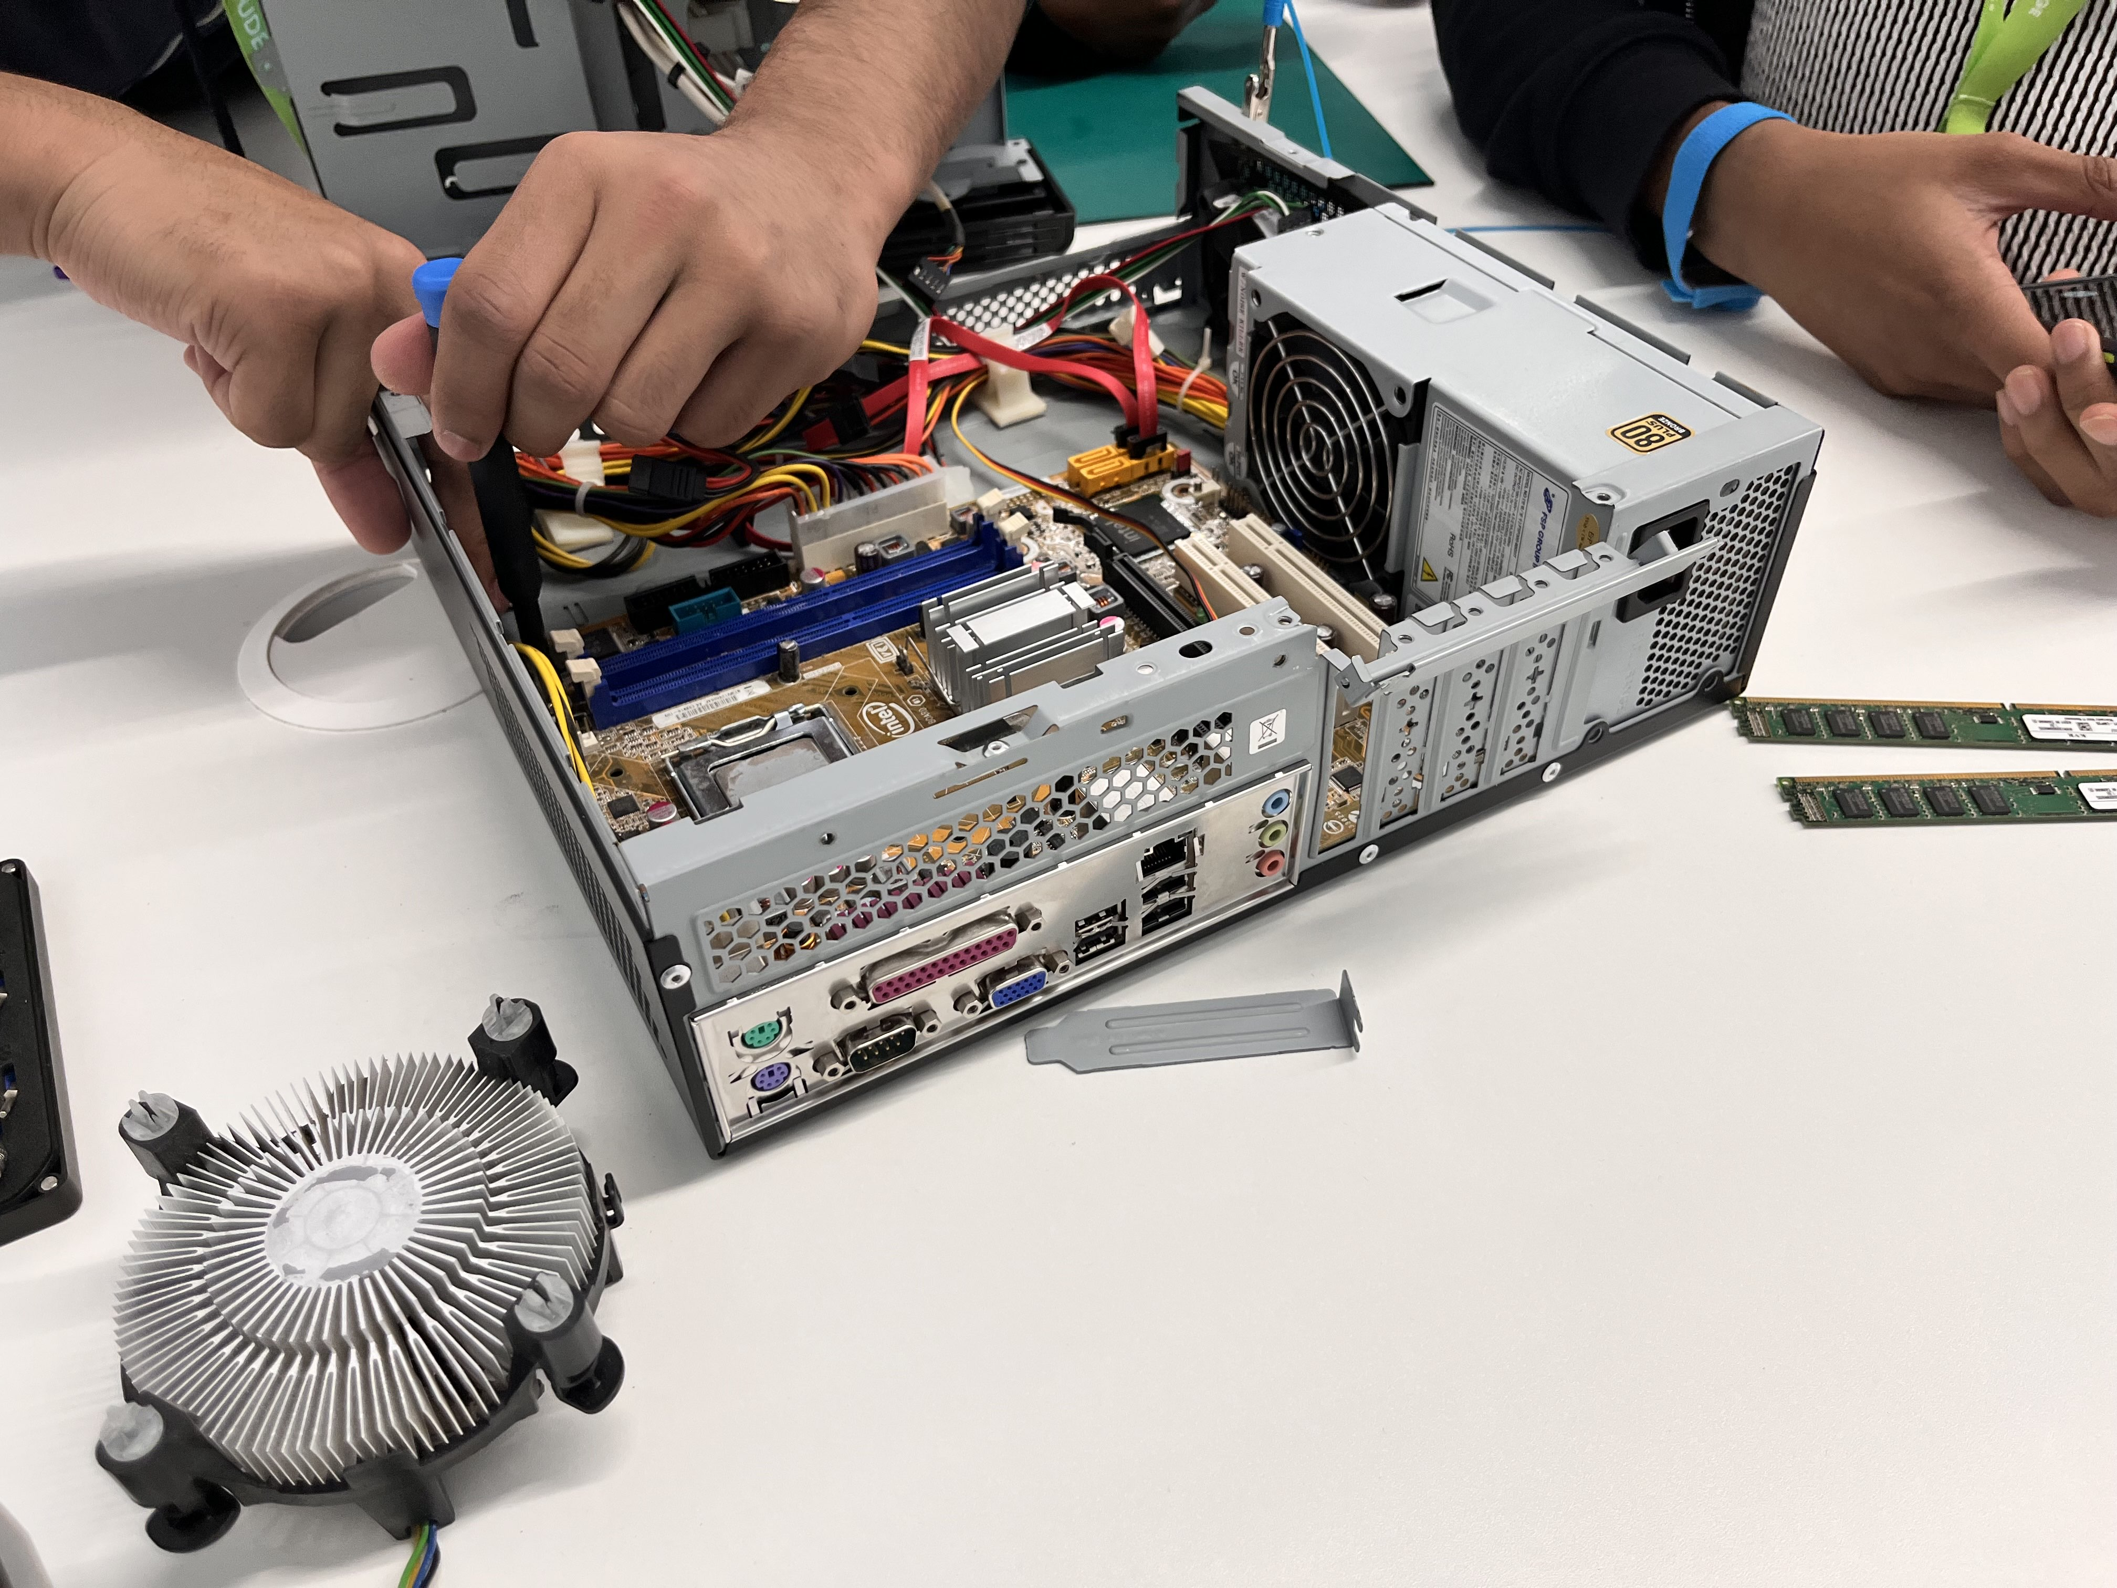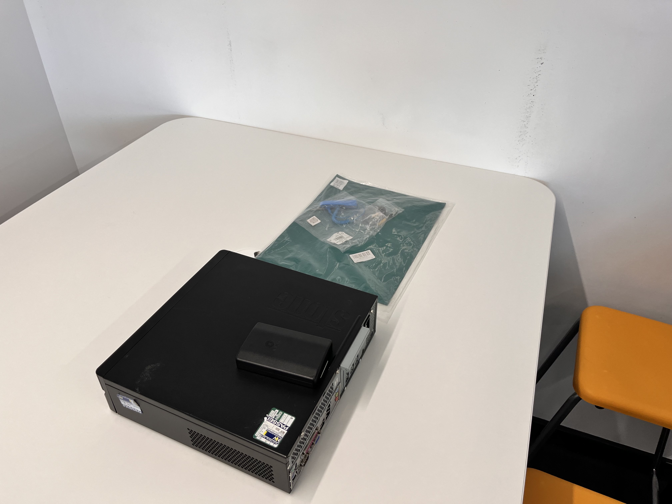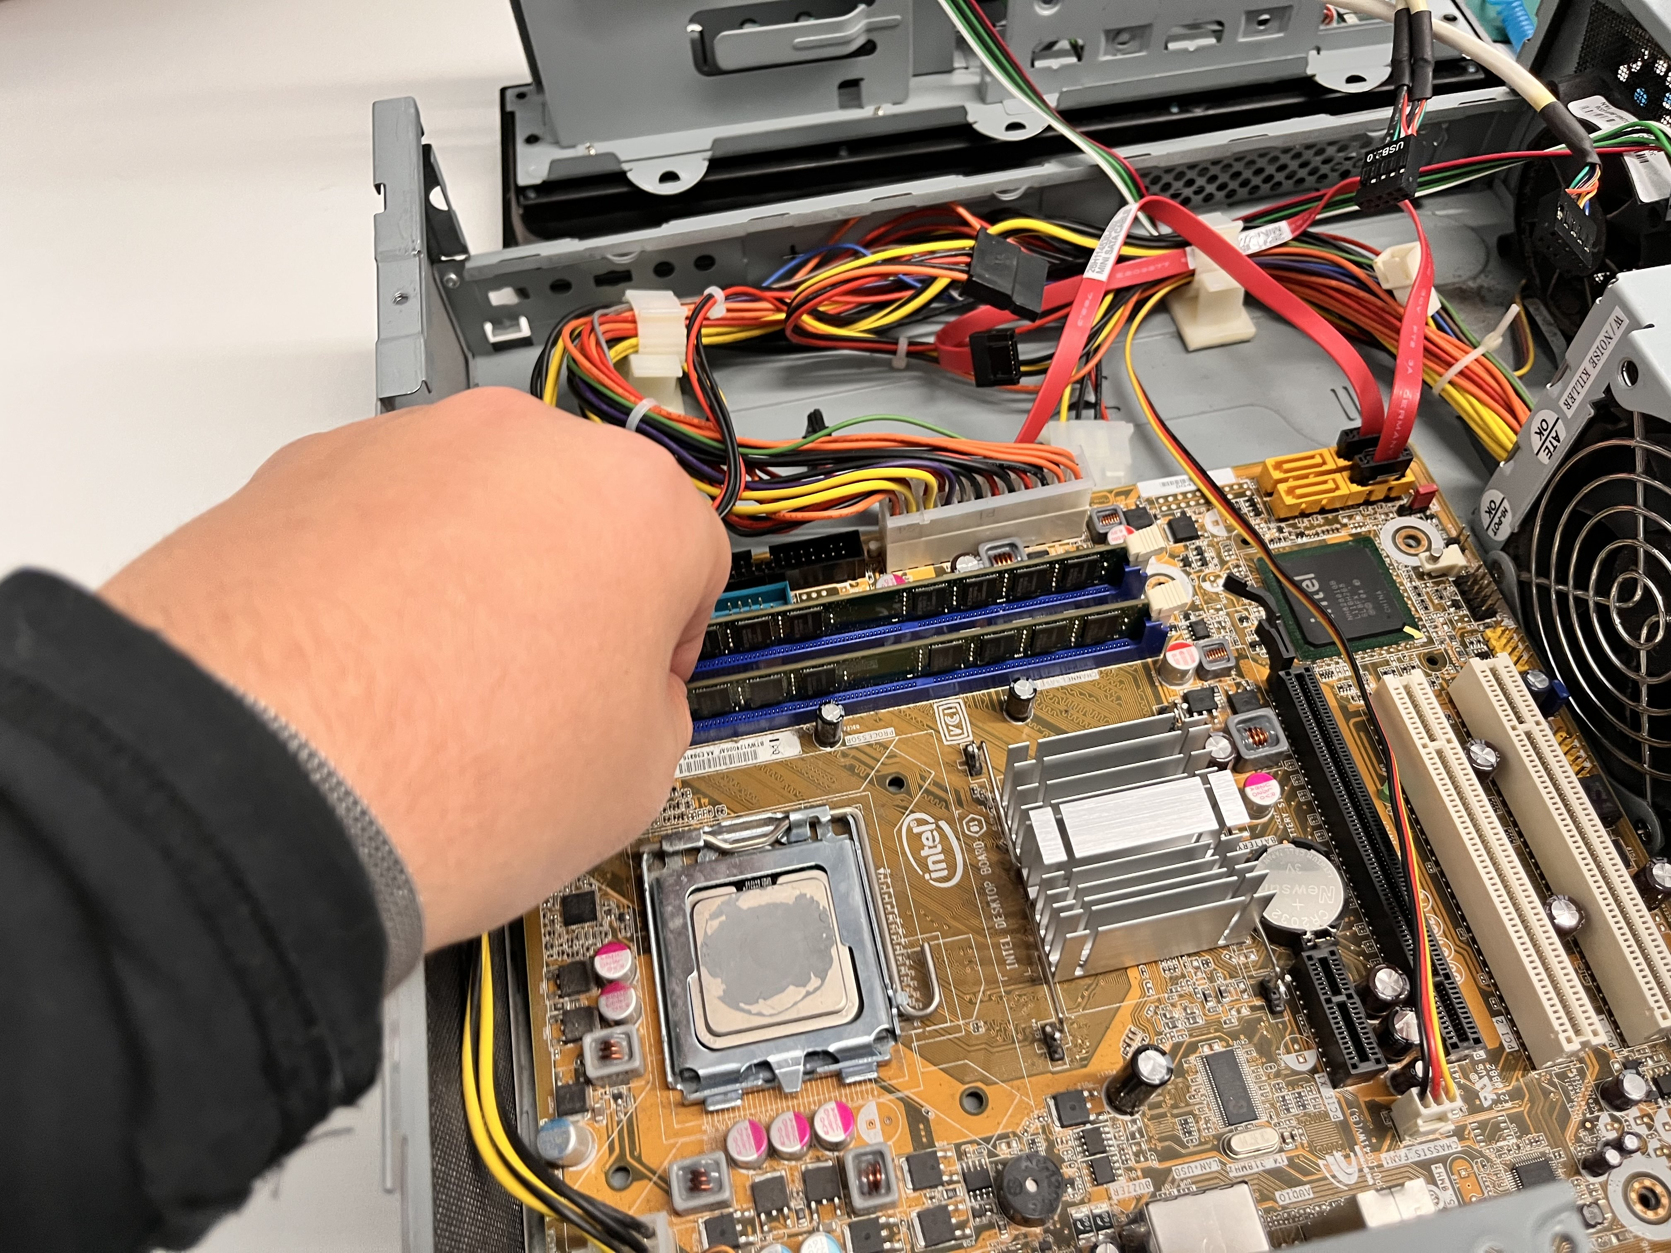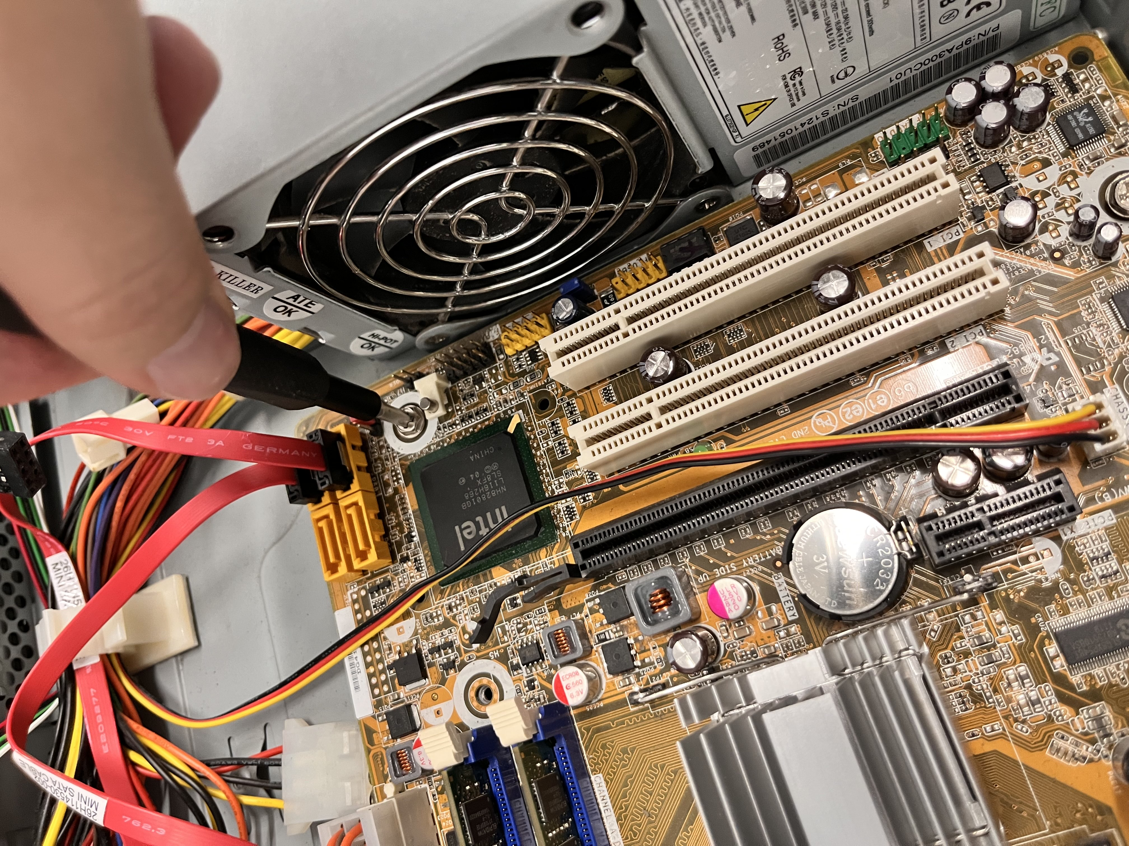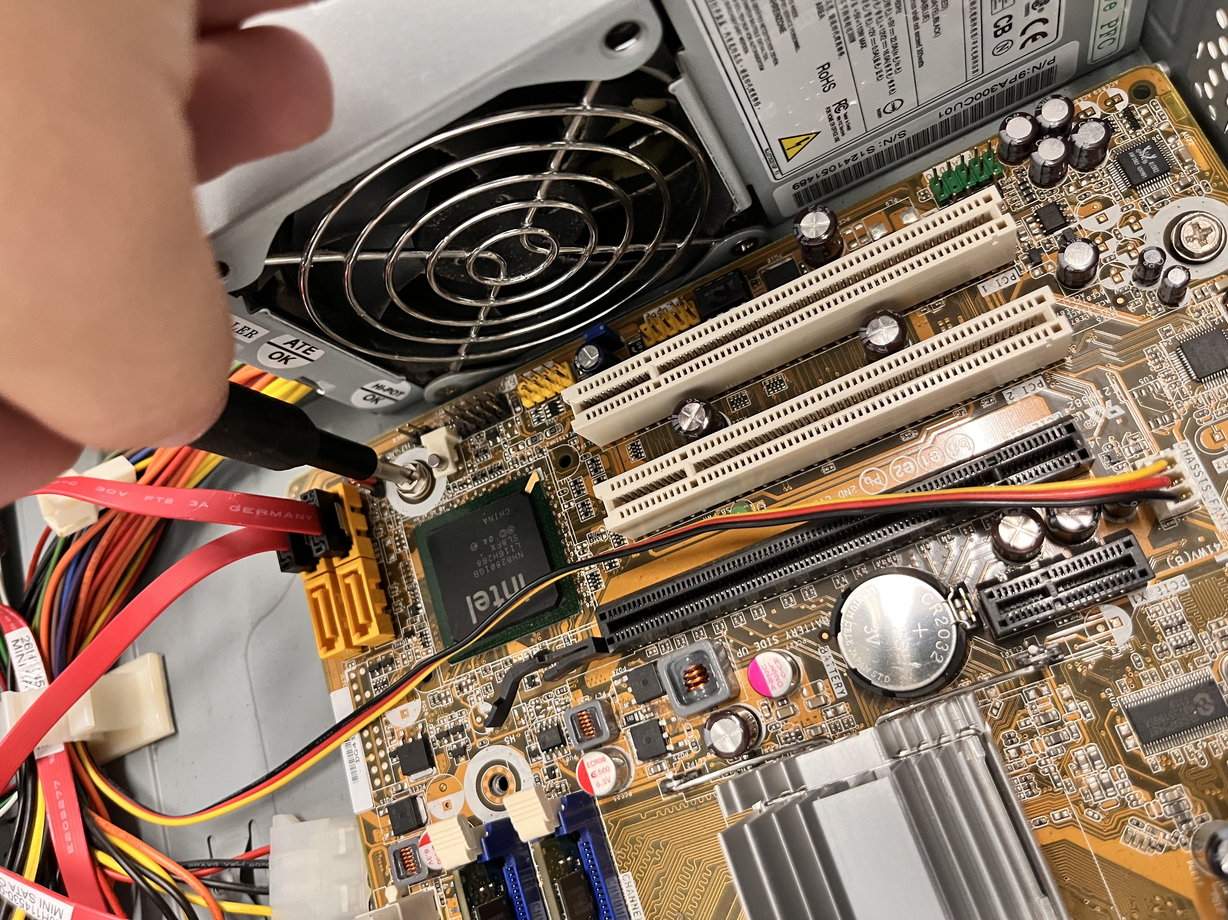

**Task 4**